CO2 – Assessment 01 22 – 10 – 2026
ANALYTICAL PROBLEM SOLVING
Course code: DSA0308
Course Name: Natural Language Processing
Reg No: 192324300 Harisha S
Question 1
Python Program: Morphological Analysis Pipeline for Document Indexing:
Input words: “connected”, “connecting”, “connection”, design a
morphological analysis pipeline for a document indexing system.
Problem Statement:
To design and implement a Python-based morphological analysis pipeline for the words “connected”, “connecting”, and “connection” by identifying roots and suffixes, classifying suffixes as inflectional or derivational, and normalizing the words for efficient document retrieval.
Explanation:
The program analyzes the words by separating them into root and suffix components and classifying the suffixes as inflectional or derivational. It normalizes all three words to the common base form connect for efficient document retrieval.
Code:
words = ["connected", "connecting", "connection"]
rules = {
"connected": ("connect", "ed", "Inflectional"),
"connecting": ("connect", "ing", "Inflectional"),
"connection": ("connect", "ion", "Derivational")
}
print("-" * 85)
print("{:<15} {:<15} {:<12} {:<18} {:<15}".format(
"Word", "Root", "Suffix", "Suffix Type", "Normalized"
))
print("-" * 85)
for word in words:
root, suffix, suffix_type = rules[word]
parsed_structure = root + " + " + suffix
normalized = root
print("{:<15} {:<15} {:<12} {:<18} {:<15}".format(
word, root, suffix, suffix_type, normalized
))
print("-" * 85)
Output:
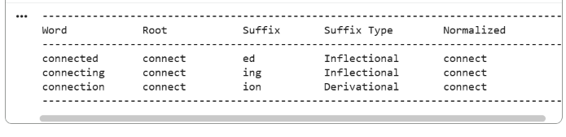
Result:
Thus, the morphological analysis program successfully identifies the roots, suffixes, suffix types, and normalized forms of the given words.

Question 2
Python Program: Morphological Parsing for Sentiment Analysis:
Input words: “unhappy”, “happiness”, “happily”, design a morphological
parsing module for sentiment analysis.
Problem Statement:
To develop a rule-based morphological parsing module for the words “unhappy”, “happiness”, and “happily” by identifying prefixes, suffixes, and base forms, classifying derivational transformations, and normalizing the words to a common root for sentiment analysis.

Explanation:
The program separates each word into its prefix, base, and suffix using predefined morphological rules. It classifies all transformations as derivational and normalizes the words to the common root happy for sentiment analysis.
Code:
words = ["unhappy", "happiness", "happily"]
rules = {
"unhappy": ("un", "happy", "None", "Derivational"),
"happiness": ("None", "happi", "ness", "Derivational"),
"happily": ("None", "happi", "ly", "Derivational")
}
print("-" * 85)
print("{:<15} {:<12} {:<12} {:<12} {:<18} {:<12}".format(
"Word", "Prefix", "Base", "Suffix", "Transformation", "Root"
))
print("-" * 85)
for word in words:
prefix, base, suffix, transformation = rules[word]
print("{:<15} {:<12} {:<12} {:<12} {:<18} {:<12}".format(
word, prefix, base, suffix, transformation, "happy"
))
print("-" * 85)
Output:
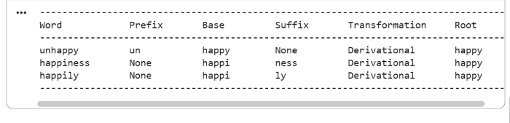
Result:
Thus, the morphological parsing module successfully identifies the morphological components and transformation types of the given words and maps them to the common root happy.

Question 3
Python Program: Stemming-Based Preprocessing Module for a Search Engine:
Input words: “played”, “player”, “playing”, design a stemming-based
preprocessing module for a search engine.
Problem Statement:
To implement a Python-based stemming module for the words “played”, “player”, and “playing” by removing suffixes, identifying stems, distinguishing inflectional and derivational forms, and generating normalized words for search engine indexing and information retrieval.
Explanation:
The program applies predefined stemming rules to remove suffixes and extract the stem play. It classifies -ed and -ing as inflectional suffixes and -er as a derivational suffix.
Code:
words = ["played", "player", "playing"]
rules = {
"played": ("play", "ed", "Inflectional"),
"player": ("play", "er", "Derivational"),
"playing": ("play", "ing", "Inflectional")
}
print("-" * 85)
print("{:<12} {:<12} {:<12} {:<18} {:<15}".format(
"Word", "Stem", "Removed Affix", "Transformation", "Normalized"
))
print("-" * 85)
for word in words:
stem, affix, transformation = rules[word]
print("{:<12} {:<12} {:<12} {:<18} {:<15}".format(
word, stem, affix, transformation, stem
))
print("-" * 85)
Output:
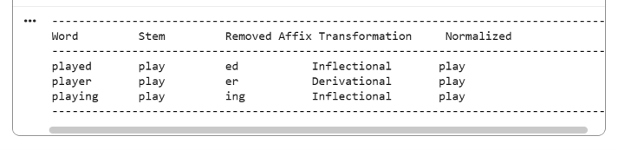
Result:
Thus, the stemming-based preprocessing module successfully extracts the stem and classifies each transformation, normalizing all three words to play for efficient search engine indexing and information retrieval.

Question 4
Python Program: Finite-State Morphological Parser:
Input words: “writes”, “writing”, “written”, design a finite-state
morphological parsing module for a text processing system.
Problem Statement:
To design and implement a finite-state morphological parser for the words “writes”, “writing”, and “written” by modeling state transitions, identifying regular and irregular verb inflections, tracing parsing paths, and mapping all forms to a common root representation.
Explanation:
The program uses predefined finite-state transition paths to identify regular suffixes and the irregular form written. It maps all three words to the common root write for consistent text processing.

Code:
words = ["writes", "writing", "written"]
rules = {
"writes": {
"root": "write",
"morphology": "write + s",
"type": "Regular",
"path": "START -> ROOT -> SUFFIX_S -> ACCEPT"
},
"writing": {
"root": "write",
"morphology": "write + ing",
"type": "Regular",
"path": "START -> ROOT -> SUFFIX_ING -> ACCEPT"
},
"written": {
"root": "write",
"morphology": "write -> written",
"type": "Irregular",
"path": "START -> ROOT -> IRREGULAR_FORM -> ACCEPT"
}
}
print("=" * 105)
print("{:<12} {:<15} {:<18} {:<15} {:<35}".format(
"Word", "Root", "Morphology", "Type", "State Transition Path"
))
print("=" * 105)
for word in words:
data = rules[word]
print("{:<12} {:<15} {:<18} {:<15} {:<35}".format(
word,
data["root"],
data["morphology"],
data["type"],
data["path"]
))
print("=" * 105)
print("\nNormalized root for all words: write")
Output:
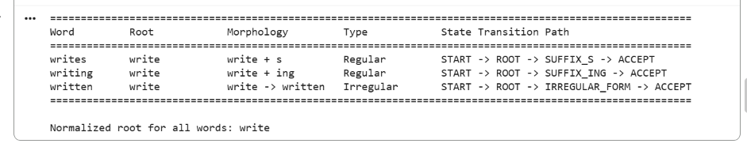
Result:
Thus, the finite-state morphological parser successfully identifies the morphological breakdown, inflection type, state transition path, and normalized root of the given words.

Question 5
Python Program: Porter Stemmer-Based Preprocessing Module:
Input words: “relational”, “relation”, “relate”, design a Porter
Stemmer-based preprocessing module for document retrieval.
Problem Statement:
To develop a Porter Stemmer-based preprocessing module for the words “relational”, “relation”, and “relate” by applying stemming rules, identifying intermediate forms and final stems, and normalizing words to improve document indexing and retrieval.

Explanation:
The program uses NLTK's PorterStemmer to apply suffix-removal rules to the input words. It reduces the three words to the common stem relat, helping improve matching during document retrieval.
Code:
from nltk.stem import PorterStemmer
ps = PorterStemmer()
words = ["relational", "relation", "relate"]
print("-" * 75)
print("{:<15} {:<25} {:<20}".format(
"Original Word", "Stemming Rule", "Final Stem"
))
print("-" * 75)
for word in words:
stem = ps.stem(word)
if word == "relational":
rule = "ational -> ate"
elif word == "relation":
rule = "Remove ion"
else:
rule = "No suffix removal"
print("{:<15} {:<25} {:<20}".format(
word, rule, stem
))
print("-" * 75)

Output:
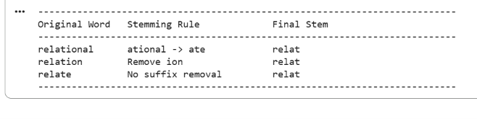
Result:
Thus, the Porter Stemmer-based preprocessing module successfully stems the given words and produces normalized forms suitable for document indexing and retrieval.

